Angular Material Radio Button

<md-input-container>

<label>Status:</label>

<input ng-model="user.status">

<md-radio-group ng-model="user.status">

<md-radio-button ng-value="true" class="md-primary">Active</md-radio-button>

<md-radio-button ng-value="false"> inActive</md-radio-button>

</md-radio-group>

**{{**user.status**}}**

</md-input-container>

$scope.user.status = true;

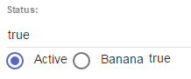

<md-radio-group ng-model="data.group1">

<md-radio-button value="Apple" class="md-primary">Apple</md-radio-button> <md-radio-button value="Banana"> Banana </md-radio-button> <md-radio-button value="Mango">Mango</md-radio-button>

</md-radio-group>

